F2 ‘How to’ Guide: Riverside Practice
Contents
Introduction 1
Sending a task 1
Order blood tests 2
Order imaging 3
Order ECG/ echo / 24h tape 4
2 week wait referrals 5
Advice and guidance 6
Referral letters 8
A&E referrals 8
Telephone advice from Homerton specialties 8

Introduction
Welcome to the Riverside Practice! I did my rotation here from December – April 2025. I put together this guide to help with the most common admin tasks that initially take a while to get to grips with. I hope you find it helpful and it makes the transition from Cerner to Emis a little easier. Any feedback or suggestions for updates or new sections would be much appreciated. Please email Kieran.mclaverty1@nhs.net. Enjoy your time at the practice.

Sending a task
- You will often be sending tasks to reception to send off referrals and other admin issues. Select the purple task icon…
- 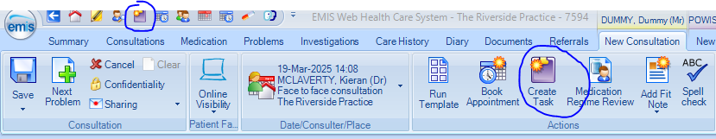
- Once clicked, make sure the ‘type’ is patient note, and ‘send to’ reception. Remember to check the urgent box at the bottom for important tasks like 2ww referrals
- 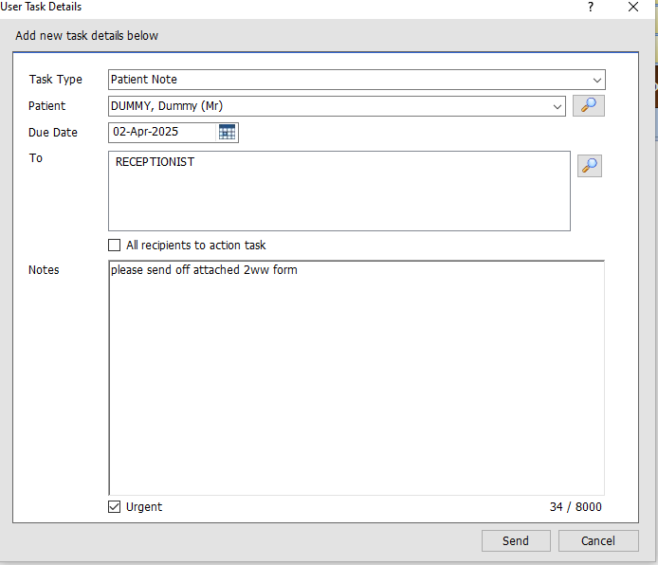
- If you have an urgent message then send a note instead (yellow icon), and it will pop up on their screen as an instant notification. This is good if you need to ask Dr Goel or Dr Rishi if you can call them to discuss a case
- 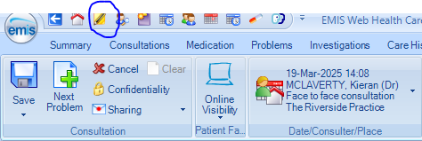
- 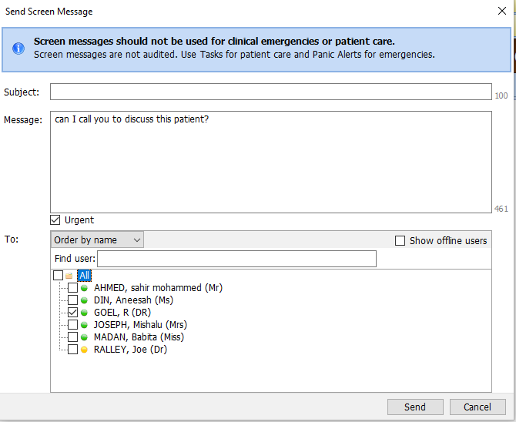

Order blood tests
Once you have opened a consultation, select ‘test requests’ and ‘online’ requests…
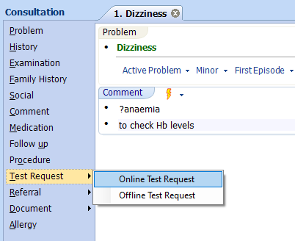
- Select Homerton University Hospital on the Next page
- Then on the request form always select Dr Goel
- 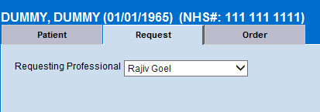
- Go to the ‘order’ tab and this is where you can select bloods. You can also select wound swabs / FIT tests/ urine MSU etc. from here. Most of these can be selected from the left panel. If you need to find more niche bloods you can search by clicking open:
- 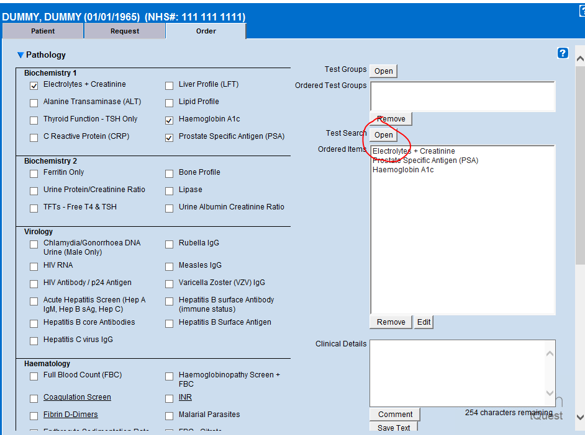
- Add clinical details and then hit save at the bottom
- You can then tell the patient to pick up a blood test form from reception. They book the test themselves at a local clinic. If they are frail reception can book them in to be done here.

Order imaging
- Imaging uses the same process as bloods (see above). You can either scroll down the panel or search for it like you would a blood test
- XR imaging is done via walk-in. Book the scan and tell patient to go to Homerton 9am-5pm Monday to Friday. Tell them to pick up a form from reception for this (but this is not vital)
- Ultrasound is done by appointment only. Once you book the ultrasound the hospital will contact the patient with the appointment date. Same with CT and MRI. You don’t need to do anything more. Importantly, if the ultrasound is urgent e.g. new neck mass – select this in the pull down tab and write in the description!
- 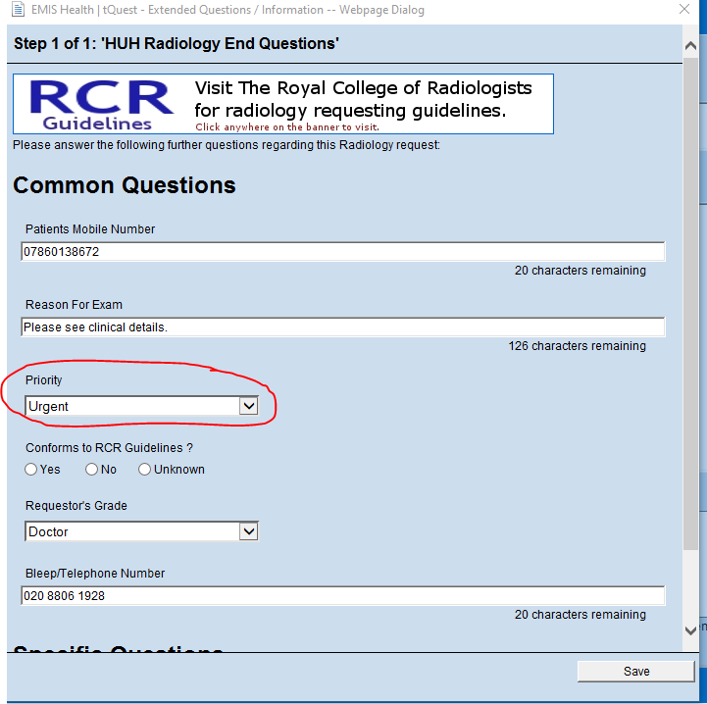
- If you want to image a mass or skin lump – the best option to select for is ‘US SOFT TISSUE’

Order ECG/ echo / 24h tape
- These are all referral forms that you need to fill out and task reception to send off. Once you have your consultation open select document create letter…
- 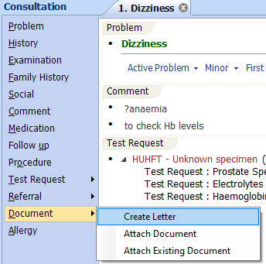
- Hit the magnifying icon to open up the full list of referral forms…
- 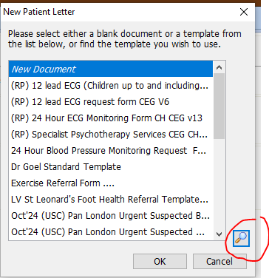
- Then to get to the referral forms click on the below files…
- 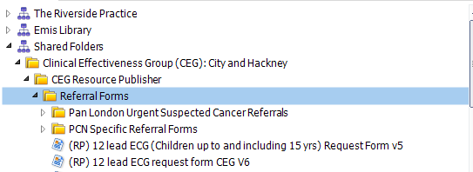
- Fill in the form and task reception with sending it off to the Homerton.

2 week wait referrals
- These are also found under documents, click on ‘pan London urgent suspected cancer referrals’ and choose from the list
- 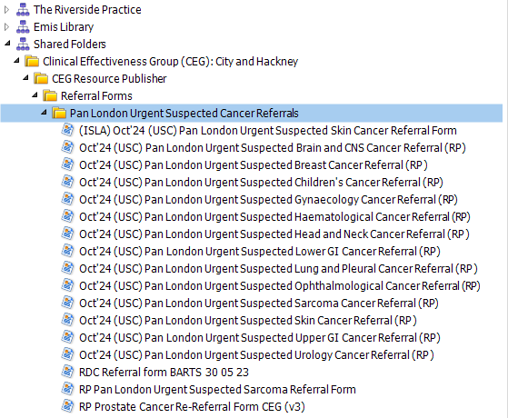
- Once you have completed the form, don’t forget to send an ‘urgent’ task reception to send this off, otherwise the referral won’t be made.
- As a safety net you should set a reminder to check up on the patient in 2 weeks to see if they have had their appointment. These reminders will go to Dr Goel. Hit F12 (Iqra can set up this shortcut for you) then launch CEG templates…
- 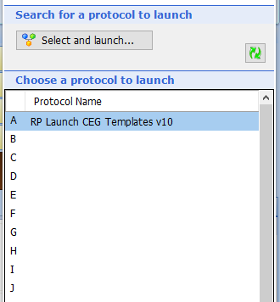
- 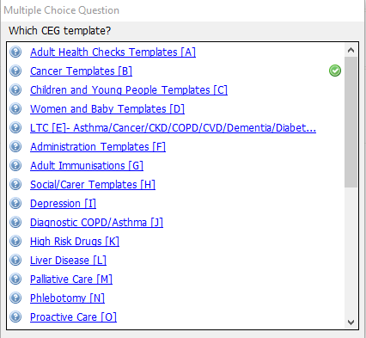
- Then ‘cancer referrals and safety netting’…
- 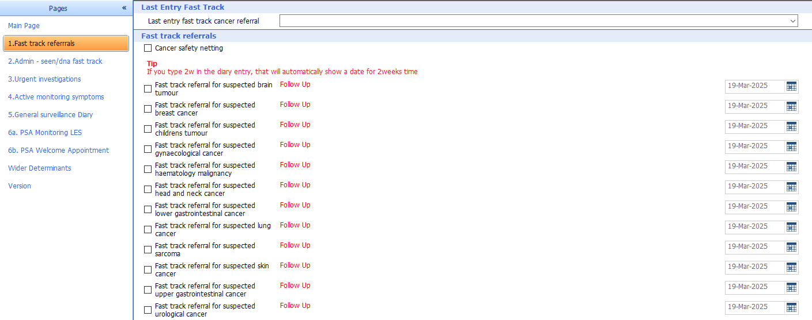

Advice and guidance
- This is a service where you can ask for specialist advice. They tend to reply quickly – within one week. If the specialist feels wants to see the patient in clinic they can convert the advice to a referral. Add the following entry in EMIS for audit “consultant advice service used”.
- Select referrals on the top bar then the e-RS tab…
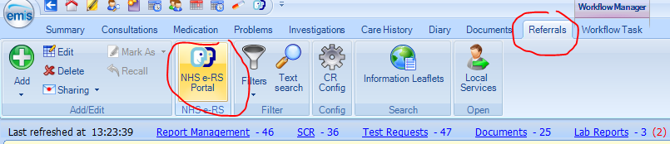
- Most of the time you will be asking for ‘advice’, and ‘routine’ priority. You do not need to put any clinical term in. Find the right specialty. Choose ‘not otherwise specified’ for the clinic type otherwise you will get only specialist centres at other hospitals. The challenge is making sure the Homerton comes up in the list of available hospitals.
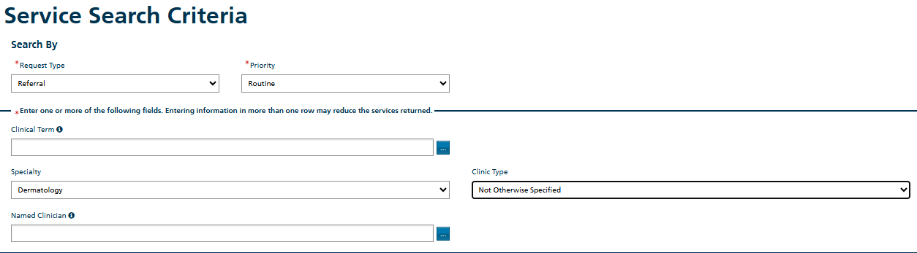
- Then choose advice and guidance at the Homerton…
- And select request in the bottom right corner
- 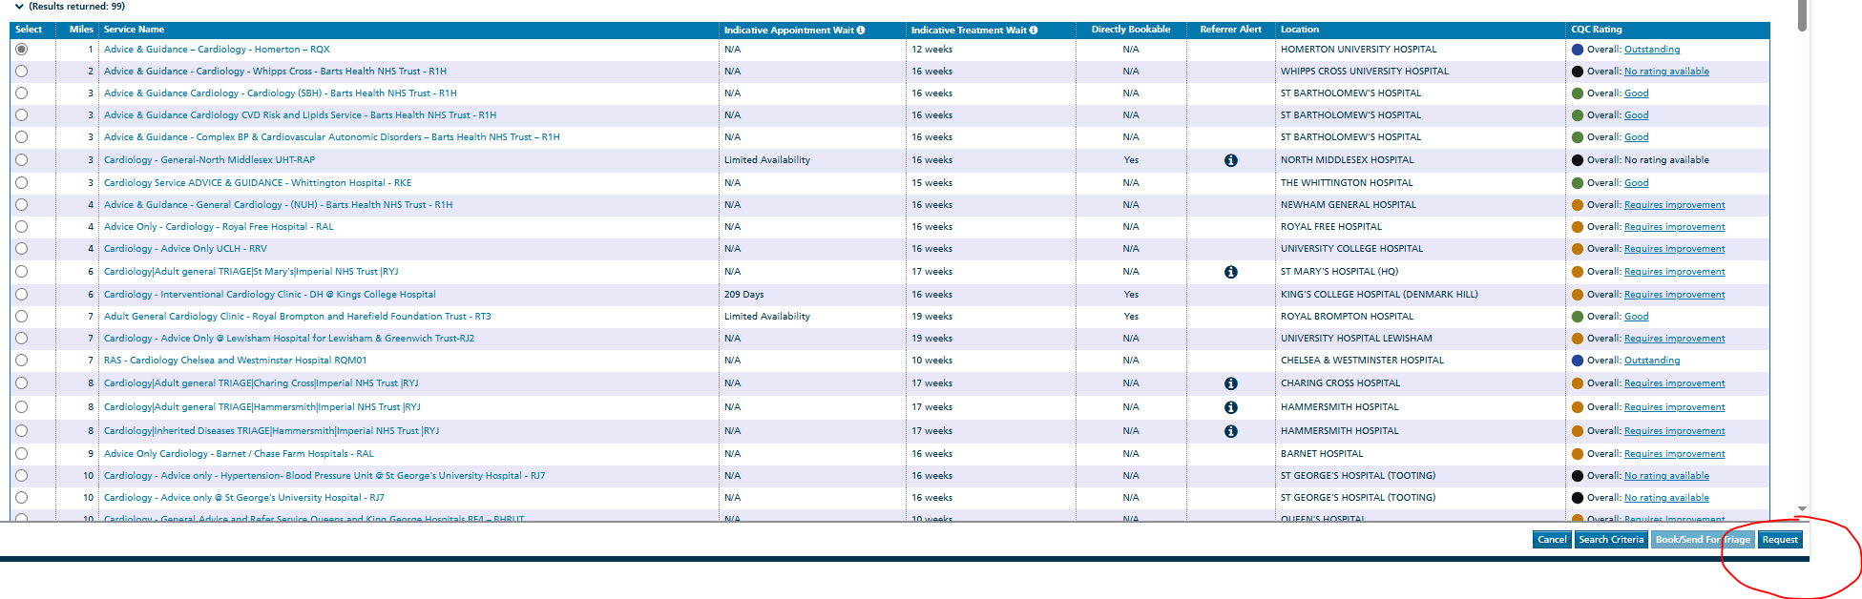
- To check on your A&G replies, navigate to the eRs homepage and select ‘worklists’
- 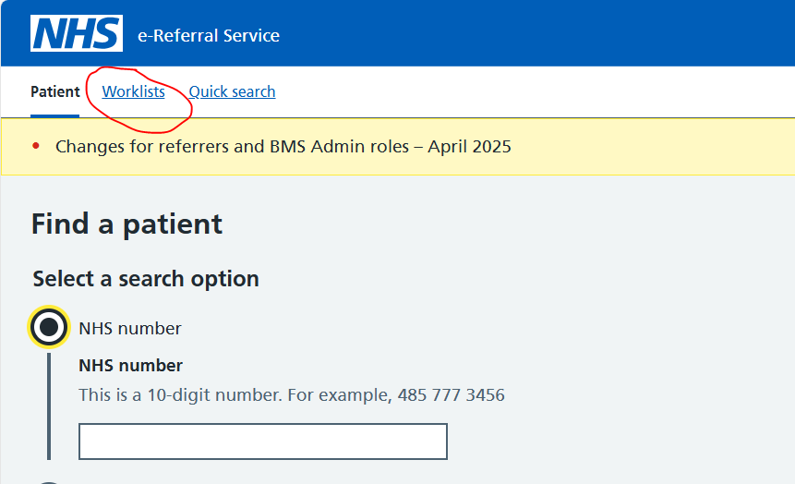

Referral letters
- For routine outpatient referrals first discuss if appropriate with Dr Goel or Dr Rishi. If agreed add the following code in EMIS, “peer review of prospective referral carried out” The process for routine referrals can be a little complicated. For most medical specialties you can write a generic letter and task reception with sending this. This generic letter can be found in the same documents tab that you use for 2ww referrals / ECGs etc. Search for ‘Dr Goel Standard Template’ and fill in the letter. Make sure to address the right department at the top .
- 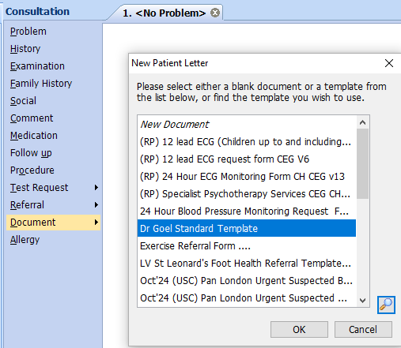
- Some referrals require you to fill in a specialised form. If in doubt ask Dr Goel / Dr Rishi about this. The most common ones that do this are: rapid access chest pain, respiratory diagnostic hublets (for spirometry) community physiotherapy, ACERS, Mental health referral forms, teledermatology (asking for advice on pictures of skin problems) and foot clinic.

A&E referrals
- Will require discussion with Dr Goel or Dr Rishi first. Send a patient with a printed referral letter – you can modify a ‘Dr Goel Standard Template’ and include the details here. You could also send this letter to their phone / email via AccuRx for them to show up at the Homerton.
- If you are sending them for a surgical or paediatric review, then call ahead via Homerton switch to inform them.
- Add the following in EMIS for audit, “referral to accident and emergency service”

Telephone advice from Homerton specialties
- An extensive list of all the urgent advice contact numbers can be found here: Urgent and Emergency Care - GP Website
- The most frequently used advice lines I use are;
  - Paediatric consultant: 07795390715: this is operational 9-5 Mon-Fri. To be used for non-urgent advice to discuss any complex cases. E.g. should this patient be referred to clinic? Any more tests we could do in GP? If you think the child should go to A&E then discuss with paeds SpR via switch
  - SDEC: 07500991259 open from 10-6pm, run by A&E or Acute Medicine consultant. Helpful if a patient needs urgent investigations / bloods but does likely not need admission into hospital. E.g. cough, borderline obs, but otherwise well – to arrange CXR and bloods.
  - Mental health 02038194957 (crisis mental health line). To discuss any acute concerns over MH. Often these teams will arrange follow up in the community. If they need urgent review they can be sent to the Raybould Crisis Hub, which is a walk-in centre next to HUH.

